Ain Shams University, Faculty of Engineering

Project Report

**24 May 2022**

Prepared by: Abdulrahman Ayman **19P6458**

Osama Ayman **19P1609**

AbdulRaouf Monir **19P4442**

Adham Ahmed **19P1250**

1. Introduction:

A university database system used for storing information related to all faculties in the university, the departments in each faculty and the courses taught by each and every department. Moreover, it also stores the information of all the individuals related to the university, whether it was a student, a lecturer, or a worker.

The university database system also specifies many relations between each entity, such as which course is taught by a certain lecturer, or which department is contained in which faculty, and which course is offered by which department, and which person belongs to a which faculty. Therefore, this database system is designed to allow the user to generate multiple reports based on the user needs.

1. Important data and reports:

2.1) Tables and Attributes:

Person: ID (PK), First Name, Second Name, Address, Date of Birth, Email, Faculty Name (FK), University Name (FK).

Faculty: University Name (PK), Faculty Name (PK), Dean, Location.

Department: Name (PK), Department Head, Faculty Name (FK), University Name (FK).

Course: Course ID (PK), Course Name, Credit Hours, Student Capacity, PreReq Course (FK), Department Name (FK), Lecturer ID (FK).

Student: ID (PK), GPA

Studies: Student ID (PK & FK), Course ID (PK & FK)

Salaried Employee: ID (PK & FK), Salary

Lecturer: ID (PK & FK), Salary

Worker: ID (PK & FK), Salary

2.2) Reports

1. Retrieve all data from course
2. Retrieve all data from department
3. Retrieve all data from faculty
4. Retrieve all data from lecturer
5. Retrieve all data from person
6. Retrieve all data from salaried employee
7. Retrieve all data from student
8. Retrieve all data from studies
9. Retrieve all data from worker
10. For each course, retrieve the course name, the number of courses where the student has a GPA greater than 1.5
11. Retrieve individual first name, and email where the individual is born after 1950-11-01
12. Calculate the worker average salary who work in Ain Shams University
13. Retrieve course names, which are pre-requisites to other courses
14. Retrieve course names, which are in the Architecture department, and have more than 5 credit hours
15. Assumption:
16. Each person must belong to one faculty, and each faculty must contain one or more people
17. A person mush be either a student or a salaried employee
18. A salaried employee must be either a lecturer or a worker
19. A lecturer must teach one or more courses, and a course must be taught only by one lecturer
20. A student must study one or more courses, and a course must be studied by one or more student
21. A course must be offered by one department only, and a department must offer one or more courses
22. A department must be contained by one faculty, and a faculty must contain one or more courses
23. EER Diagram:

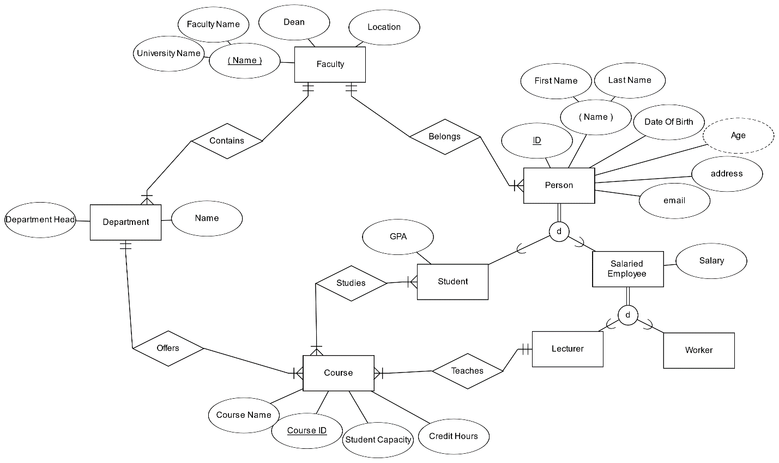

1. Database Schema:

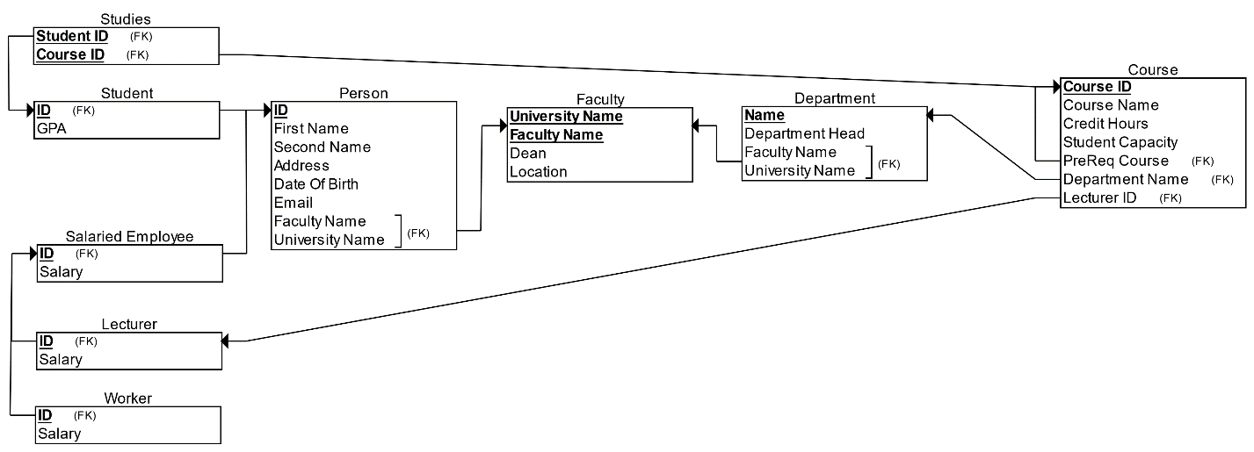

1. Sample Of SQL:

6.1) Create:

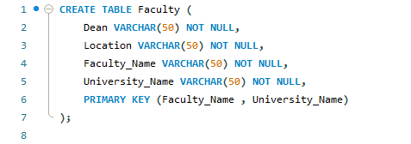

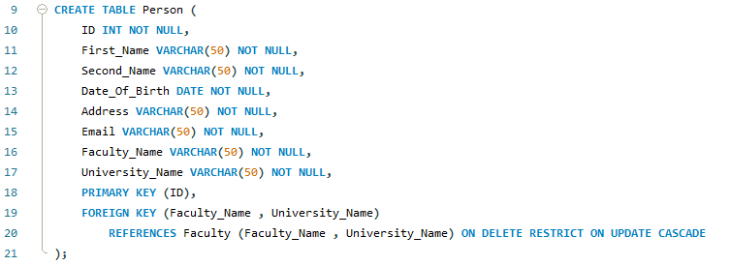

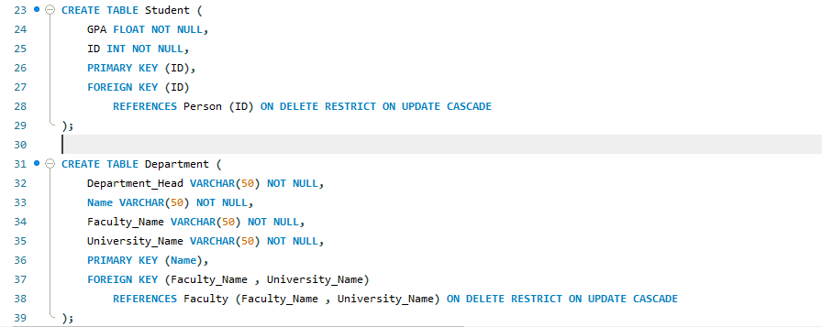

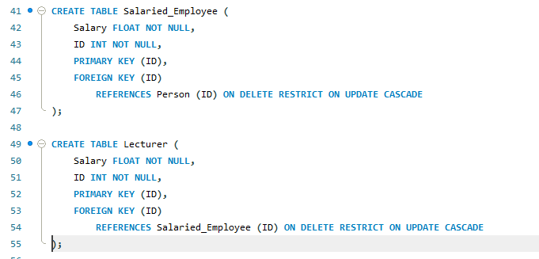

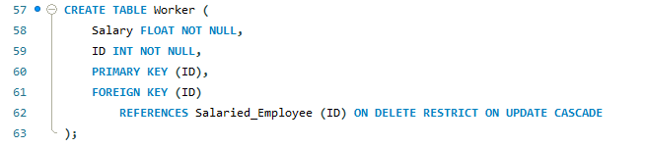

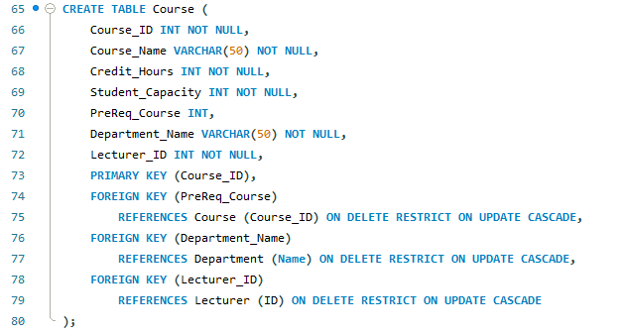

6.2) Insert:

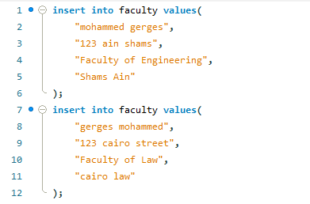

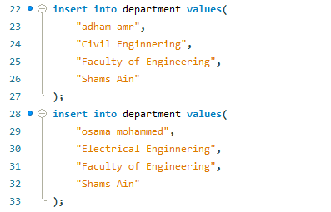

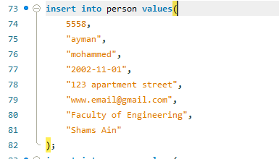

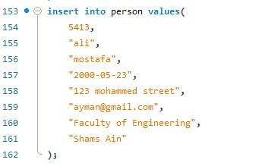

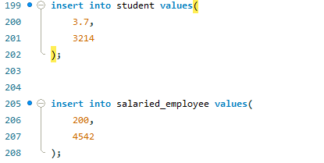

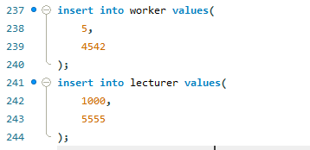

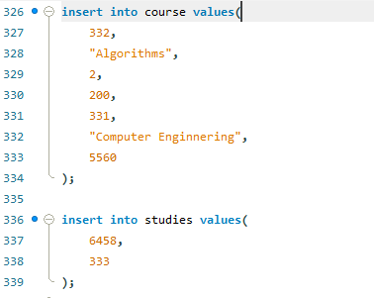

6.3) Update:

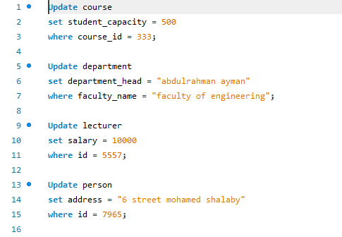

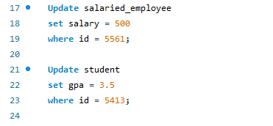

6.4) Delete:

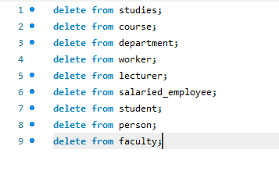

6.5) Reports:

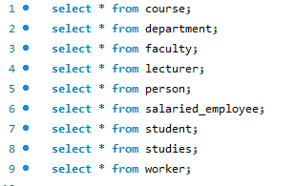

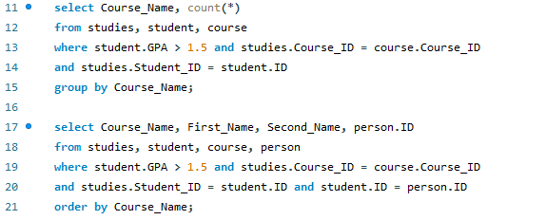

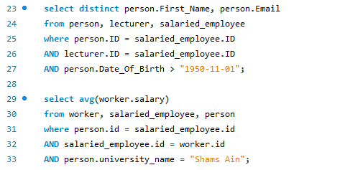

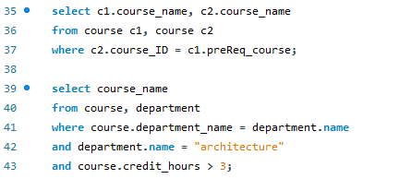

1. Implementation:

7.1) Part1: using ERD tool:

ERDPlus is one of the best free database modelling tools online. With the availability of a ton of features, you can create entity relationship diagrams, relational schemas and star schemas with ease. The best part is there's a brief guide on how to create your ER diagrams especially for beginners, you can also easily convert your created ER diagrams to relation schemas.

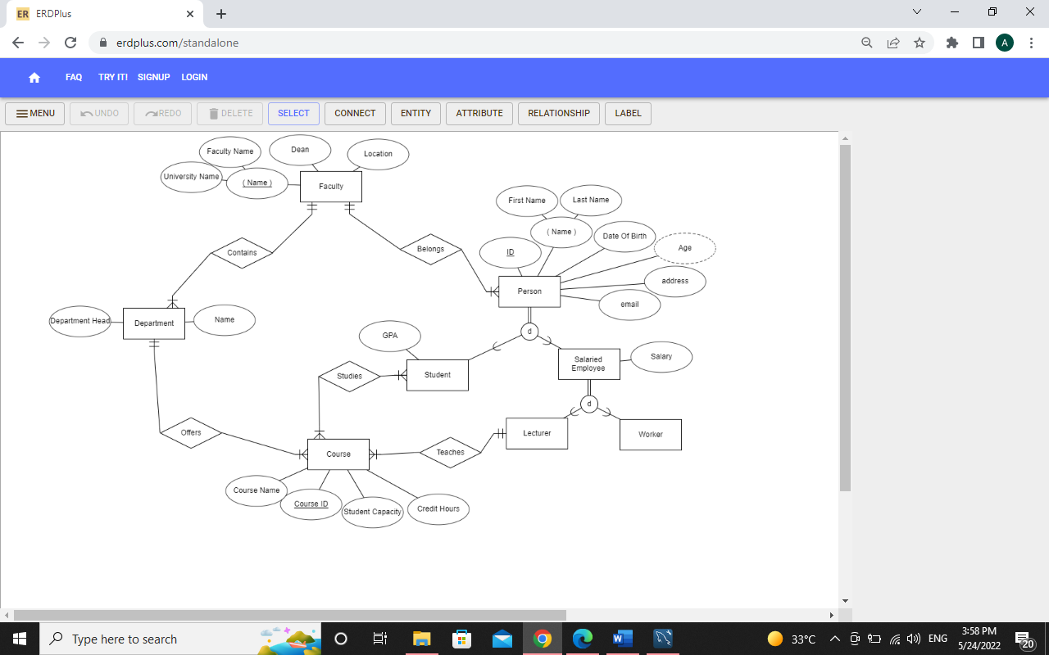

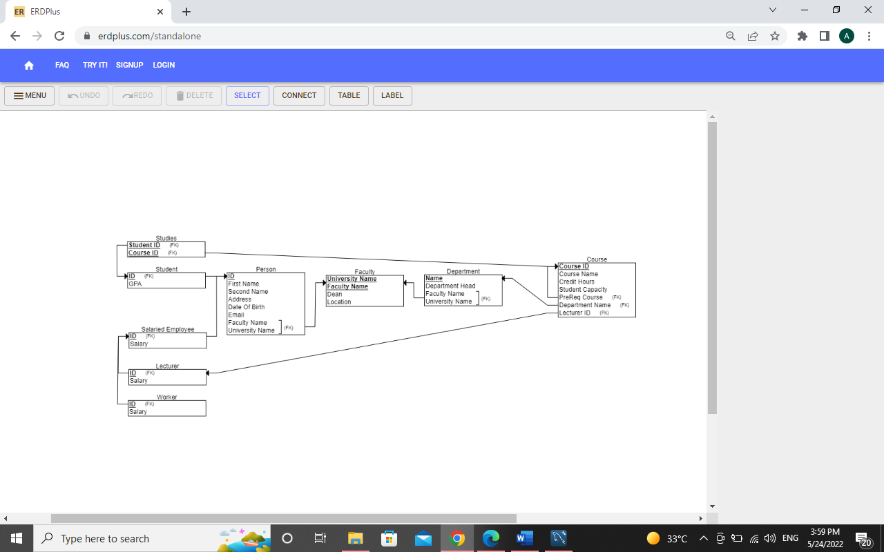

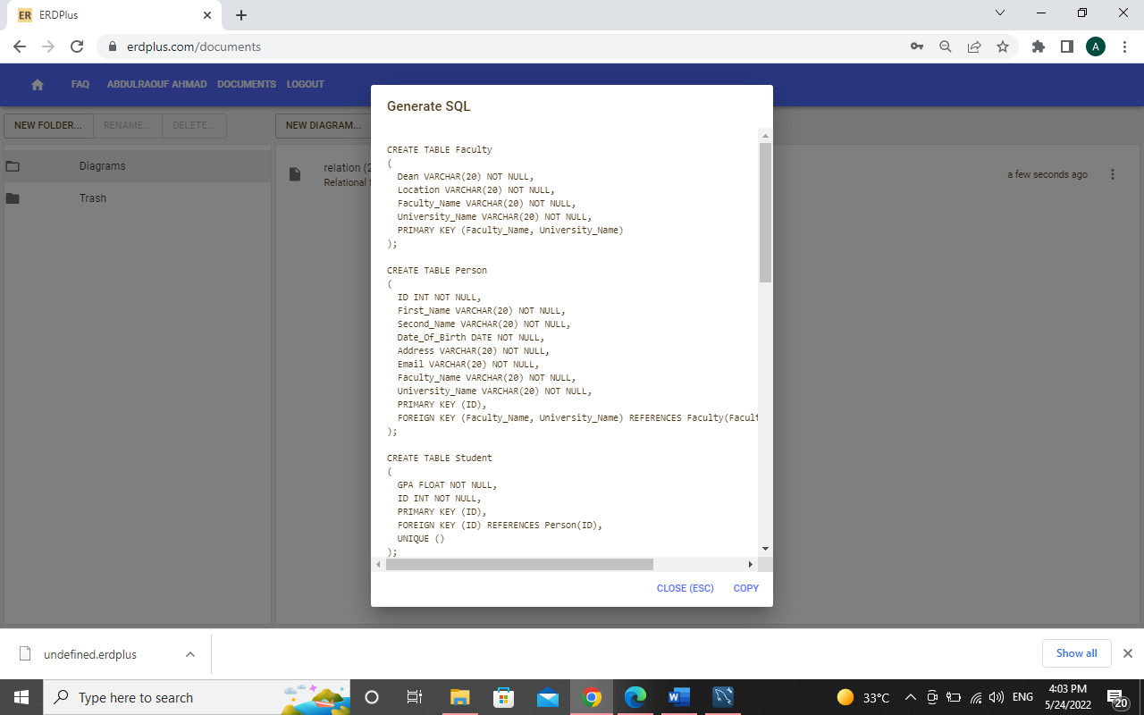

7.2) Part2: using SQL tool:

MySQL is an open-source relational database management system. As with other relational databases, MySQL stores data in tables made up of rows and columns. Users can define, manipulate, control, and query data using Structured Query Language, more commonly known as [SQL](https://www.digitalocean.com/community/tutorials/what-is-sql). MySQL’s name is a combination of “My,” the name of MySQL creator Michael Widenius’s daughter, and “SQL”.









